**Social Media News Tracking System**

Project Plan

By

**Mr. Pichet Potha 542115041**

**Mr. Sittipong Borripan 542115066**

Department of Software Engineering

College of Arts, Media and Technology

Chiang Mai University

Project Advisor

________________________________

**Dr. Chartchai Doungsa-ard**

**Document History**

|  |  |  |  |  |  |  |
| --- | --- | --- | --- | --- | --- | --- |
| **Document name** | **Version** | **Status** | **Date** | **Viewable** | **Reviewer** | **Responsible** |
| **Documents** | | | | | | |
| **SMTS-Project Plan_Version 0.1.docx** | 0.1   * Introduction * Work Product to be developed * Acronym and Definition * Infrastructure | Draft | July  9,2015 | PP, SB, CD | PP, SB | PP, SB |
| **SMTS-Project Plan_Version 0.2.docx** | 0.2   * Management Procedures * Quality Planning * Estimate Duration of Task * Risk Management * Configuration Management * Reference | Draft | July  9,2015 | PP, SB, CD | PP, SB | PP, SB |

**Table of Contents**

Chapter One | Introduction…………………………………………………………...……………………...1

1.1 Project Overview ………………..…………...………………………......……………….........1

1.2 Document Overview …………………………………………………………………………...1

Chapter Two | Literature Review.…….…………………………………………………….…………….…2

2.1 Deliverables …………………………………………………………………………………..2

Chapter Three | Acronym and Definition ……………………………………….…...……………………...3

3.1 Acronym………..………………..…………...………………………......……………….........3

3.2 Definition…………..…………………………………………………………………………...3

Chapter Four | Infrastructure…………………………………………………….…...……………………...5

4.1 Software Resource ………..……………..…...………………………......……………….........5

4.2 Hardware Resource …………..……………………………………………………………...5

Chapter Five | Management Procedures ……………………..………………….…...……………………...6

5.1 Project Team Structure ………..……………..…...………….………......……………….........6

5.2 Monitoring and Controlling Mechanisms ……………………………………………………...6

5.3 Change Management.………..……………..…...……………………......……………….........7

Chapter Six | Quality Planning………...……………………..………………….…...……………………...8

5.1 Quality Factors……….………..……………..…...………….………......……………….........8

5.2 Review/Responsibility……...…………………..……………………………………………...8

5.3 Testing……………………………….….……………………………………………………...9

5.4 Quality Standard…....………..……………..…...……………………......……………….........9

Chapter Seven | Estimate Duration of Task ………...…………..……………….…...…………………….10

7.1 Schedule Plan..……….………..……………..…...………….………......……………….......10

7.2 Estimate Duration of Task ……...……………….…………………………………………….11

7.3 Estimated Effort and Cost...………….….…………………………………………………….11

7.4 Milestones…….…....………..……………..…...……………………......……………….......12

Chapter Eight | Risk Management…………………………………………………...…………………….15

8.1 Risk Management Process...………………..…………...……………......……………….......15

8.2 Risk Identification and Solutions……………………………………………………………….16

Chapter Nine | Configuration Management……………………..…………….…...……………………...17

9.1 Naming Conversion…..………..……………..…...………….………......……………….......17

9.2 Project Repository……………………………………………………………………………………….18

9.3 Configuration Item Table…………………..…...……………………......……………….......19

Chapter Ten | Reference…………………….……………………..…………….…...………….…………20

**Chapter One | Introduction**

* 1. **Project Overview**

**Project Name: Social Media News Tracking System**

Social Media News Tracking System is the system that is proposed for searching the status, posts, an article on the website “Pantip, Facebook, and Twitter” that be the popular social network in Thailand. The system will find the content that match with the word that already set or enter by the user, and gathering those contents from all of the posts in these three websites and show them to the user. The system can tags that word for alert the user to know when there is the new posts or content that relate to the tags occurred. It will make the user knows about this so fast. The user can go to answer or do something to make the rumor clear and save the reputation before it was damaged.

**1.1.1 Project Scope**

Social Media News Tracking System is a responsive web application that run on the web browser. It will help user can search and check the rumor on the threes popular social network in Thailand including “Pantip, Facebook, and Twitter”. It will crawl on these social media application and analyzes the media post by the users. If the content of the media is related to what the user interest, the application will alert the users so the user can handle the situation as soon as possible.

* + 1. **Objective**
  + To help user can found the status, post, or the article that already occur in the social network and relate with what user interested.
  + To alert the user when the system found the new status, post, or the article that will be created in the social network later and make user can handle the situation as soon as possible if the content is not true.

**1.2 Document Overview**

This document consists of the details of the development plan to implement Social Media News Tracking System project. The document includes the plan and the schedule to do the work, and the management process to control the quality of the each process to make the standard for the system. Members will work following this plan during each process.

**Chapter Two | Work Product to be developed**

**2.1 Deliverables**

|  |  |  |  |
| --- | --- | --- | --- |
| **No.** | **Document** | **Software** | **Date** |
| 1. | Project Proposal   * Proposal v.1.0 | - | 10th June 2015 |
| 2. | The progress report I   * Software Requirement   Specification v1.0   * Project Plan v1.0 * Software Design   Document v1.0   * Test Plan v1.0 * Test Record v1.0 * Traceability Record v1.0 * Progress status report | **Feature**   * Feature 2: Searching System | 28th August 2015 |
| 3. | The progress report II | **Feature**   * Feature 1: User Management system * Feature 3: Tracking System | 23th September 2015 |
| 4. | The progress report III (Show Pro) | **Feature**   * Feature 4: Real-time alert system | 18th November 2015 |

**Chapter Three | Acronym and Definition**

**3.1 Acronym**

**SRS** Software Requirement Specification

**URS** User Requirement Specification

**VSE**  Very Small Entity

**PP** Mr.Pichet Potha

**SB** Mr.Sittipong Borripan

**CD** Dr.Chartchai Doung sa-ard

**SMTS** Social Media News Tracking System

**3.2 Definition**

|  |  |
| --- | --- |
| **Name** | **Description** |
| **IEEE** | Institute for Electrical and Electronics Engineers. Biggest global interest group for engineers of different branches and computer scientists. [IEEE90] |
| **Integration Testing** | The progressive linking and testing of software components in order to ensure their proper functioning in the whole system. [IEEE90] |
| **Milestone** | A significant event in the project, usually completion of the main deliverable. [IEEE90] |
| **Plan** | A documented series of tasks requires meeting an objective, typically including the associated schedule, budget, resources, organizational description and work breakdown structure. [IEEE90] |
| **Project management** | The application of knowledge, skills, tools, and techniques to project activities in order to meet or exceed stakeholder needs and expectations from a project. [IEEE90] |
| **Project Plan** | A formal, approved document used to guide both project execution and project control. The primary uses of the project plan are to document planning assumptions and the decision, to facilitate communication among stakeholders, and to document approved scope, cost, and schedule baseline. [IEEE90] |
| **Risk** | An uncertain event or condition that, if it occurs, has a positive or negative effect on a project’s objectives. It is a function of the probability of occurrence of a given threat’s occurrence. [IEEE90] |
| **Risk management** | The systematic application of management policies, procedures and practices to the tasks of identifying, analyzing, evaluating, treating and monitoring risk. [IEEE90] |
| **System testing** | Testing conducted on a complete and integrated system for evaluate the system’s compliance with its specified requirements [IEEE90] |
| **Traceability** | The ability to trace the history, application or location of an item or activity, or work products or activities, by means of recorded identification. The establishment and maintenance of relationships between such items. Horizontal traceability describes the relationship between work products of the same type (e.g., Customer requirements). Vertical traceability describes the relationship between work products, which build or derived from each other (e.g., From customer requirements to qualification test cases). Bidirectional traceability allows to directly following relationships in both directions. [IEEE90] |
| **Validation** | Confirmation by examination and provision of objective evidence that the particular requirements for a specific intended use are fulfilled (“doing the right thing”). Part of quality control. [IEEE90] |
| **Verification** | Confirmation at the end of the process by examination and provision of objective evidence that specified requirements to the process have been fulfilled (“doing things right”). Part of quality control. [IEEE90] |
| **UML** | Unified Modeling Languages. Standardized notation for modeling design descriptions, architectures or scenarios. Not depending on a specific method. Issued and maintained by the object Management Group (OMG). [IEEE90] |
| **Unit test** | A test of individual programs or modules in order to remove a design or programming errors. [IEEE90] |

**Chapter Four | Infrastructure**

**4.1 Software Resource**

|  |  |
| --- | --- |
| **Items** | **Details** |
| **Web Browser** | * Chrome desktop 44.0.2403.157 m; Chrome for Android 44.0.2403.133 * Firefox 39.0; Firefox for Android 34.0.1 |
| **Database** | * MySQL 5.6.26 |
| **Tools** | * NetBeans IDE 8.0.2 |
| **Technology** | * Spring Framework * Responsive web design (Bootstrap) * JSOUP |

**4.2 Hardware Resource**

|  |  |
| --- | --- |
| **Items** | **Details** |
| **Laptop 1** | Operating System : Window 10 Enterprise  Processor : Intel® Core™ i3 2.53 GHz  RAM : 4GB  Hard Disk : 320GB |
| **Laptop 2** | Operating System : Window 10 Pro  Processor : Intel® Core™ i5 2.5 GHz  RAM : 4GB  Hard Disk : 700GB |
| **Smart phone** | Sony Xperia Z Android 5.0.2 |

**Chapter Five | Management Procedures**

**5.1 Project Team Structure**

|  |  |
| --- | --- |
| **Staff** | **Activity** |
| Mr.Pichet Potha  Mr. Sittipong Borripan | Research project |
| Project Proposal |
| Project Requirement |
| Project Plan and Design |
| Implement |
| Testing |
| Review |

**5.2 Monitoring and Controlling Mechanisms**

**5.2.1 Software Development Models**

**Iterative Software Development Process**

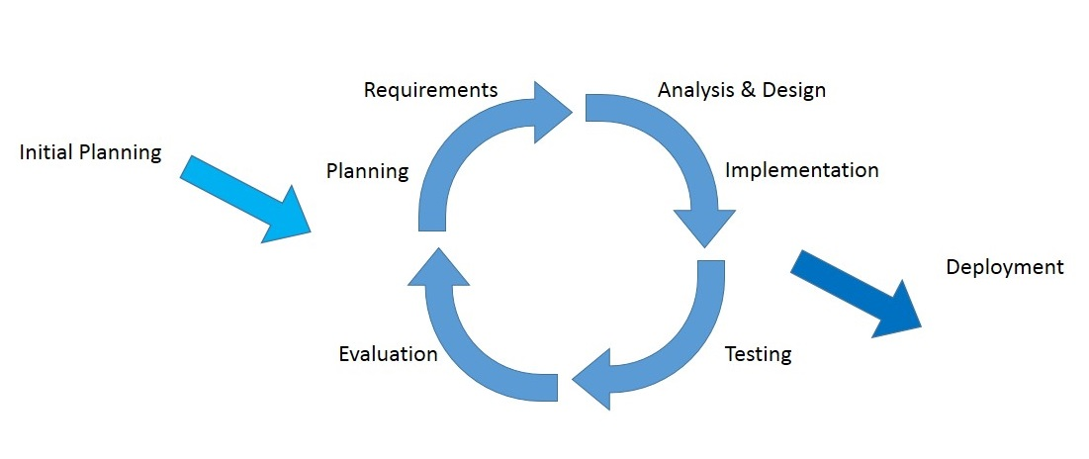

Figure 1: The diagram of the iterative software development process

The idea of the iterative software development model [1] is to divide the development process into phases. As shown in Figure 8, the iterative process begins by implementing and specifying a portion of the software instead of specifying the full requirements. It is then reviewed along the way to find and add more requirements as needed. The model is broken down into increments containing a number of smaller life cycle stages with each part including a new function to the product. And each phase must be completed before the start of the next phase and the iterations continues until the entire product is built. Some of the advantages of the iterative development model include: more flexible to accommodate feedback from customers in each cycle, easy to implement sub-systems (or components) that satisfy user requirements, easy to fix errors that occur in the implementation process.

**5.3 Change Management**

**Change control procedure**

1. Admit the change.

2. Analyze the reason for the change.

3. Send change form to project advisor.

3.1 If accept: make a change in project from change request form.

3.2 If reject: Continue in the project and find the way to solve a problem.

4. Analyze the result from changing and modify the document or system to match with change.

**Change Form:**

|  |  |  |  |  |
| --- | --- | --- | --- | --- |
| **Name of Request** | **e.g. Change Plan** | **Number of Request** | | **e.g.** 01 |
| **Project Name** | **e.g.** Social Media News Tracking System | | | |
| **Configuration Item Name** | **e.g.** SMTS_Project Plan | **Version** | **e.g.**0.1 | |
| **Requested Date** | **e.g.** 18/08/2015 | | | |
| **Description of the requested change** | **e.g.** Change submission date from 18/08/2015 to 28/08/2015 | | | |
| **Impact** | **e.g.** No Impact | **Phase** | e.g. Progress Report I | |
| **Requester** | **e.g.** Pichet Potha, Sittipong Borripan | | | |
| **Approver (**Project advisor**)** |  | | | |

**Chapter Six | Quality Planning**

**6.1 Quality Factors**

According to McCall’s factor model, the Social Media News Tracking System should meet these quality factors after complete:

**Product operation factors**

* **Correctness**
* The system be tested 10 times, at least 8-9 times must correct
* **Reliability**
* The failure rate of system should be less than 10% - 20%.
* **Maintainability**
* The system should be updated when new failures occur in the future.
* **Testability**
* The system should able to test all function.
* **Portability**
* The sys should support at least 2 devices.
* **Reusability**
* The system should able to further development.

**6.2 Review/Responsibility**

|  |  |  |  |
| --- | --- | --- | --- |
| **Stage Exit Review** | | | |
| **No.** | **Stage** | **Review Item** | **Responsibility** |
| 1. | Requirements gathering and analysis | Project Proposal | PP, SB |
| 2. | Requirements gathering and analysis | Development Plan | PP, SB |
| 3. | Requirements gathering and analysis | Software Requirement  Specifications | PP, SB |
| 4. | Requirements gathering and analysis | Traceability Record | PP, SB |
| 5. | System Design | Software Design  Document | PP, SB |
| 6. | Implementation | Code | PP, SB |
| 7. | Testing | System test Record | PP, SB |
| 8. | Testing | Unit test Record | PP, SB |

**6.3 Testing**

|  |  |  |
| --- | --- | --- |
| **Test Process** | | |
| **No.** | **Test** | **Responsibility** |
| **1.** | Unit test | PP, SB |
| **2.** | System Testing | PP, SB |
| **3.** | Acceptance Testing | PP, SB |

**6.4 Quality Standard**

**ISO29110 for Very Small Entity (VSE)**

ISO29110 is a guide applies to a Very Small Entity (VSE) [2], enterprise, organization, department or project up to 25 people, dedicated to software development. The Guide provides Project Management and Software Implementation processes which integrate practices based on the selection of ISO/IEC 12207- Systems and Software Engineering —Software Life Cycle Processes and ISO/IEC 15289 Software Engineering – Software Life Cycle Process – guidelines for the content of software life cycle process information products (documentation) standards elements.

**Project Management process**

The purpose of the Project Management process is to establish and carry out in a systematic way the tasks of the software implementation project, which allows complying with the project’s objectives in the expected quality, time and cost.

**Selected process**

Project Planning Process

Project Plan Execution Process

Project Assessment and Control Process

Project Closer Process

**Software Implementation process**

The purpose of the Software Implementation process is the systematic performance of the analysis, design, construction, integration and tests activities for new or modified software products according to the specified requirements.

**Selected process**

Software Implementation Initiation Process

Software Requirements Analysis Process

Software Architectural Design Process

Software Construction Process

Software Integration and Test Process

Software Delivery Process

**Chapter Seven | Estimate Duration of Task**

**7.1 Schedule Plan**

|  |  |  |  |
| --- | --- | --- | --- |
| **Milestone** | **Task** | **Milestone Criteria** | **Planned date** |
| 1 | Progress Report I | * Software requirement specification * Feature 2 * Software design document * Test Plan * Feature implemented * Feature test report * Traceability record progress I * Progress report I submitted * Progress report I presentationSTMS-Proposal Milestone.jpg | 18th June – 27th August |
| 2 | Progress Report II | * Feature 2, Feature 3 * Software design document * Test Planed * Feature implementation * Feature test report * Traceability record progress II * Progress report II submitted * Progress report II presentation | 5th September – 22nd September |
| 3 | Progress Report III | * Feature 1, Feature 4 * Software design document * Test Planed * Feature implementation * Feature test report * Traceability record progress III * Progress report III submitted * Progress report III presentation | 2nd Octorber – 17th November |

**7.2 Estimate Duration of Task**

|  |  |  |  |
| --- | --- | --- | --- |
| **Task and Estimate Duration** | | | |
| No. | **Phase** | **Submission Date** | **Estimate Duration(Days)** |
| 1. | Progress report I | 8th August 2015 | 71 |
| 2. | Progress report II | 23th September 2015 | 18 |
| 3. | Progress report III | 18th November 2015 | 47 |

**7.3 Estimated Effort and Cost**

Most of the cost will come from reference or learning textbook and hard copy document. Because of this project use only open source language and freeware tool for development, so most costs from this project use for buying some textbook and printing document.

**7.4 Milestones**

**7.4.1 Progress report I Milestone**

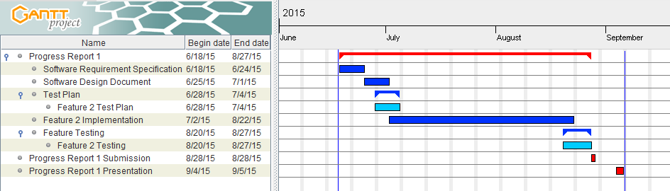

Figure 2: Progress report I Milestone

**7.4.2 Progress report II Milestone**

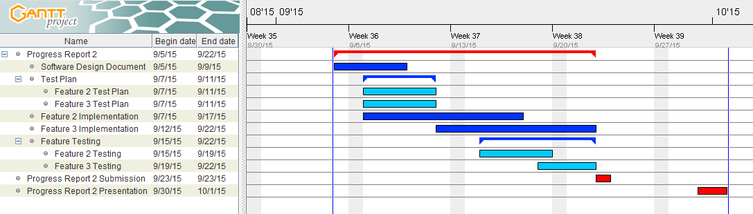

Figure 3: Progress report II Milestone

**7.4.3 Progress report III Milestone**

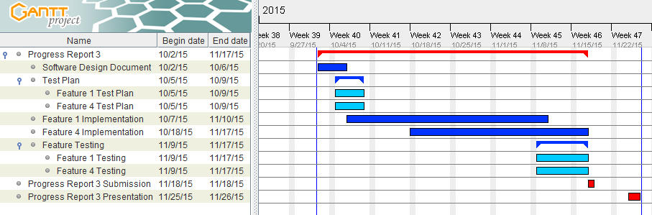

Figure 4: Progress report III Milestone

**Chapter Eight | Risk Management**

**8.1 Risk Management Process**

Risk management concerned with identifying risks and plans to minimize their effect on the project such as scope or complexity.

* Define the Risk Management Process
* Identify Risks
* Perform a Quantitative and Qualitative Risk Assessment
* Create a Risk Response Plan
* Monitor Risk

All identified risk are documented in the Risk Management Process by the Project Team. In the Risk Management Process defines the possible risk and solution of them.

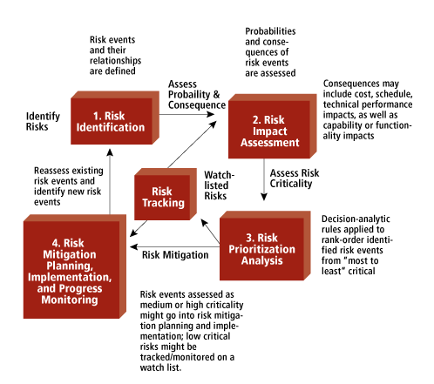

Figure 5: Risk Management Process Model [3]

**8.2 Risk Identification and Solutions**

|  |  |  |
| --- | --- | --- |
| **Risk** | **Solution** | **Priority** |
| **Human Risks** | | |
| Group members lack the skill and Knowledge. | Learn from a textbook, websites and ask someone who can help to solve the problem. | Medium |
| There is the bad communication between group members. | Try to understand each other and exchanges more information together**.** | Medium |
| **Technology Risks** | | |
| Problem with the server connection. | Give the extra time to connect with the server or change the network. | Medium |
| A computer crashes or the files are corrupted. | Keep all of the project resources in the project repository. | High |
| **Process Risks** | | |
| The submission date is changed. | Update the project plan accordingly and try to finish all the works before the new submission date. | High |
| Some features cannot complete following the defined plan. | Update the plan to compensate the delay. Move some of the tasks to the next phase if necessary. | Medium |
| The requirement may changed. | Meet and discuss with other stakeholders and analyze what changes are required. Plan for the possible changes and impact to the schedule. | High |

**Chapter Nine | Configuration Management**

**9.1 Naming Conversion**

For naming conversion, the name of document and software will be named as following format:

“[Project Name]_[Document Name] _ [Version].[File Type]”

* **Project Name**

This part will be the name of this project that is “SMTS”

* **Document Name**

This part will depend on substance of that file. In each file will has its certain name as following:

* **Proposal**
* **Project Plan**
* **Software Requirement Specification (SRS)**
* **Design Document**
* **Test Plan**
* **Test Record**
* **Traceability Record**
* **Software Source Code**
* **Show pro video**
* **Poster**
* **Version**

This part is the version of document. Version number will be in the following format:

“Version [Main version].[Sub version]”

* **Main version:**  is the main of version software and document. For example Version 1.0, the number 1 is the main version. It might refer to feature of software.
* **Sub version:**  is a part of main for developing. Subversion will has update more than the main version.
* **File Type**

This part is the type of file or the file extension. For example, .docx, .pdf.

**9.2 Project Repository**

**GitHub**

GitHub is a Web-based Git repository hosting service, which offers all of the distributed revision control and source code management (SCM) functionality of Git as well as adding its own feature [4]. GitHub can help to manage the version of document and software. Developers can share file or update version of file anytime that they want. Developers have to have their account of GitHub. Then the developers can create the project file and can share it with anyone they want.

For Social Media News Tracking System, we will create the folders to be the project repository as following:

Senior Project

Proposal

Project Plan

Software Requirement Specification

Design Document

Test Plan

Test Record

Traceability Record

Source Code

Other

Figure 6: Repository of Social Media News Tracking System

**List of related document and description**

* + **Proposal:** contain involving proposal files.
  + **Project plan:** contain project plan document files.
  + **Software Requirement Specification:** contain a software requirement specification document file.
  + **Design Document:** contain design and diagram document files.
  + **Test Plan:** contain test plan document files.
  + **Test Record:** contain test record document files.
  + **Traceability record:** contain traceability record document.
  + **Source code:** contain source code of project.
  + **Others:** contain kind of picture, server information, interesting web site and etc.

**9.3 Configuration Item Table**

|  |  |  |  |  |  |  |
| --- | --- | --- | --- | --- | --- | --- |
| No. | Item | File Name | File Type | Owner | Path | Baseline ver. |
| 1. | Project Proposal | SMTS_Proposal_Version 1.0 | .docx | PP, SB |  | 1.0 |
| 2. | Development and Quality Plan | SMTS_Project Plan_Version 1.0 | .docx | PP, SB |  | 1.0 |
| 3. | Software Requirement Specification | SMTS_SRS_Version 1.0 | .docx | PP, SB |  | 1.0 |
| 4. | Traceability Record | SMTS_ Traceability Record_Version 1.0 | .docx | PP, SB |  | 1.0 |
| 5. | Design  Document | SMTS_Design Document_Version 1.0 | .docx | PP, SB |  | 1.0 |
| 6. | Software Source Code |  |  | PP, SB |  |  |
| 7. | Test Plan | SMTS_Test Plan_Version 1.0 | .docx | PP, SB |  | 1.0 |
| 8. | Test Record |  |  | PP, SB |  |  |

**Chapter Ten | Reference**

[1] Wikipedia, “Iterative and incremental development” [Online]. Available: <https://en.wikipedia.org/wiki/Iterative_and_incremental_development> . [Accessed 24th June 2015].

[2] Wikipedia, “ISO 29110” [Online]. Available: <https://en.wikipedia.org/wiki/ISO_29110> . [Accessed 24th June 2015].

[3] MITRE, “Risk Management”, [Online]. Available: <http://www.mitre.org/publications/systems-engineering-guide/acquisition-systems-engineering/risk-management> . [Accessed 24th June 2015].

[4] Wikipedia, “GitHub” [Online]. Available: <https://en.wikipedia.org/wiki/GitHub> . [Accessed 24th June 2015].